**Documentation for Fresh desk Customer success (support desk)**

**Customer success**

**Customer success**, **customer success management**, or **client advocate** is the process of increasing customers’ satisfaction while using a product or service. Customer success is a specialized form of customer relationship management. An effective customer success strategy typically results in decreased customer churn and increased up-sell opportunities. The goal of customer success is to make the customer as successful as possible, which in turn, improves customer lifetime value (CLTV) for the company.

**Freshdesk customer success**

## Take a data-driven approach to proactively help customers achieve their goals, faster.

Freshdesk Customer Success provides full visibility into customer health metrics with proactive workflows for onboarding, renewals, and beyond. Alert customer support teams before it’s too late and protect your bottom line.

**Navigation Menus**

**1- Dashboard**

**2- Tickets**

**3- Contacts & Companies**

**4- Social**

**5- Solutions**

**6- Forums**

**7- Analytics**

**8- Admin**

**Dashboard**

**The data displayed for ticket’s action ( No. of unresolved, overdue, Due Today, Open, on hold and unassigned )**

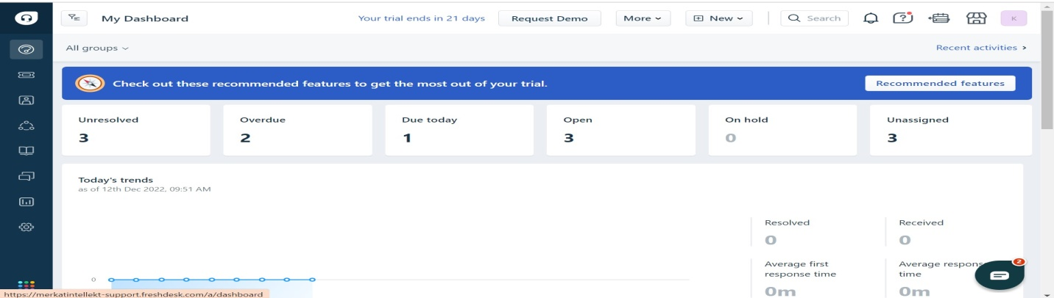

**At the top of the corner , we have a search bar for groups to find which group we want to choose**

**(Eg:)**

**All groups**

**Billing**

**Customer support**

**Escalation**

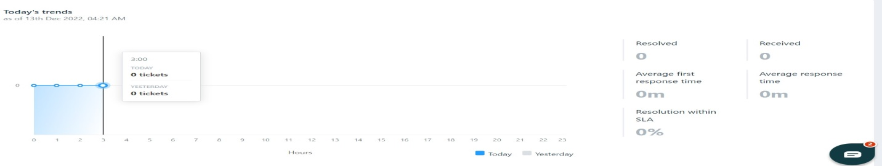

**Today’s trend Analytics**

|  |  |
| --- | --- |
| **Performance** | **Data type** |
| Resolved | Integer |
| Received | Integer |
| Average first response time | Data shows in minutes |
| Resolution within SLA | Data shows in minutes |

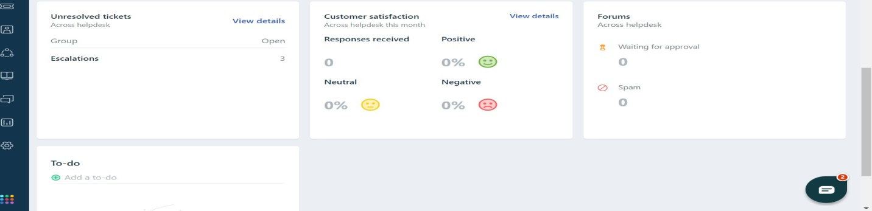

**Click on view details , It navigates to unresolved tickets page.**

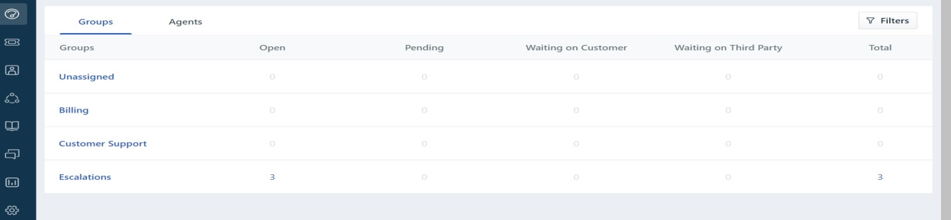

|  |  |
| --- | --- |
| **Group name** | **Data type** |
| Unassigned | Integer |
| Billing | Integer |
| Customer Support | Integer |
| Escalations | Integer |

**They have added one more option called “ Agents”**

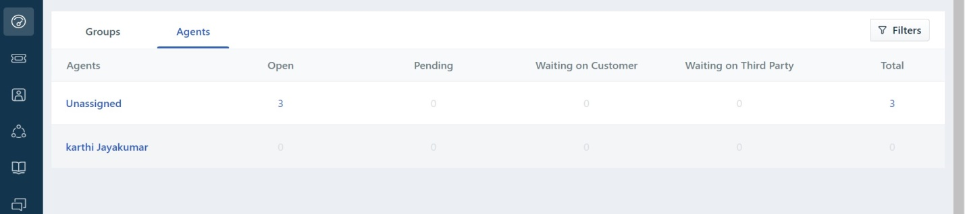

|  |  |
| --- | --- |
| **Agents** | **Data type** |
| Unassigned | Integer |
| Karthi Jayakumar | Integer |

**In filter**

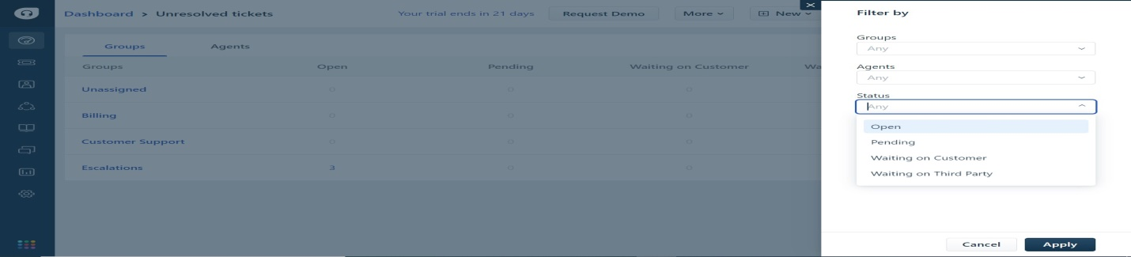

In this above filter option, we can filter the data by groups, agents and status.

**Customer satisfaction view details**

Click on view details, it navigates to customer satisfaction page

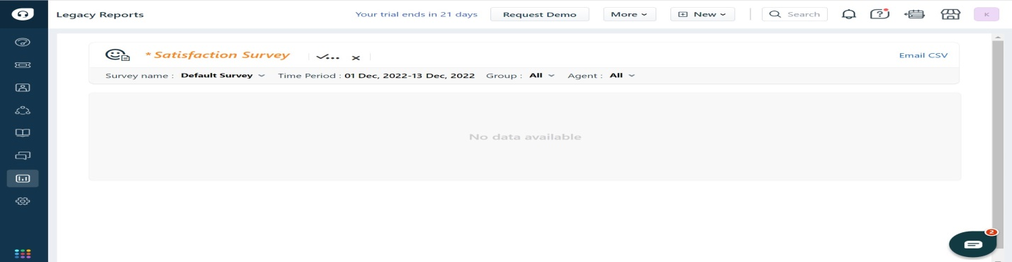

Currently, there is no data available in this page.

|  |  |
| --- | --- |
| **Report options** | **Type** |
| Save as report | Report has been saved on current page. |
| Sent to email | We can send the report through mail. |

**Forums**

There is two functions one is waiting approval another one is spam

**To-Do**

We can create daily task on this (To-do) board.

**New**

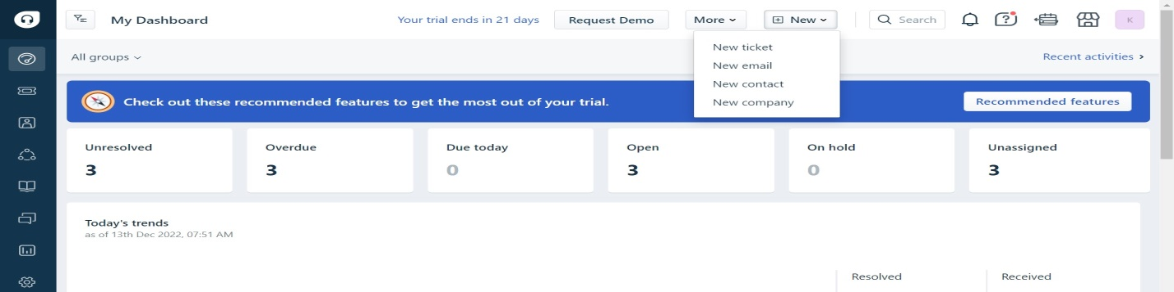

Click on new, we can create new ticket, email, contact and company through new menu.

**New ticket**

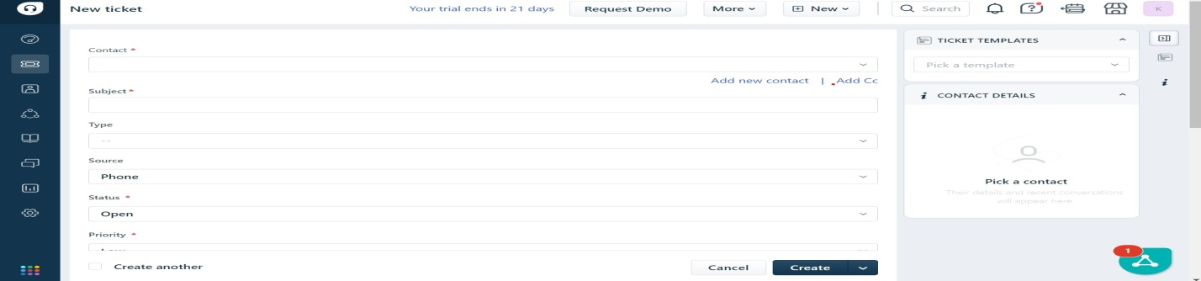

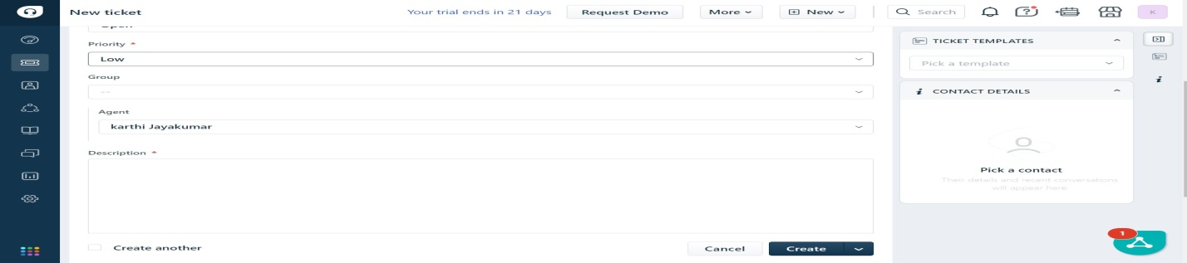

**New mail**

We can send mail with additional details

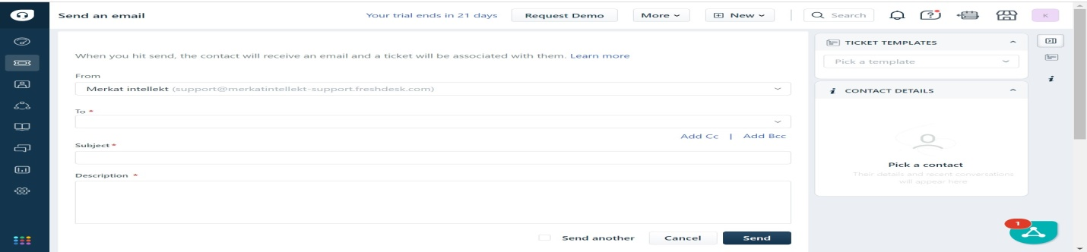

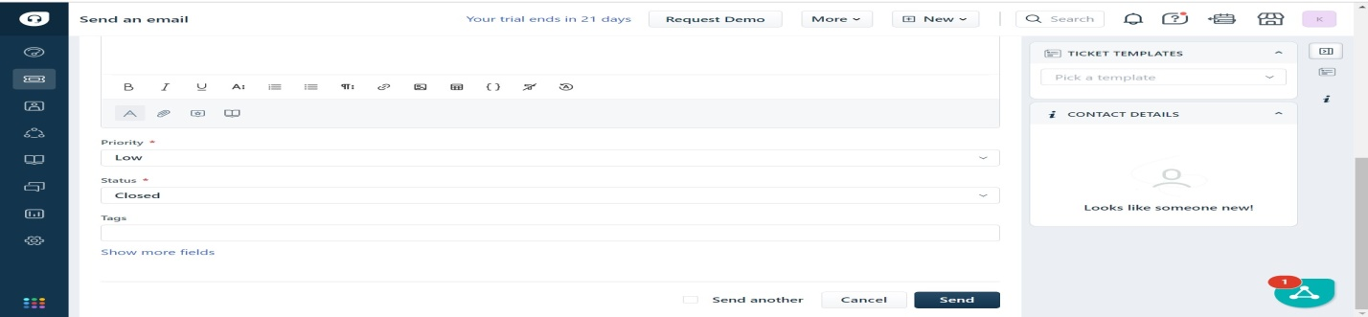

**New Contact**

Click on new ticket, we can create new contact through this option

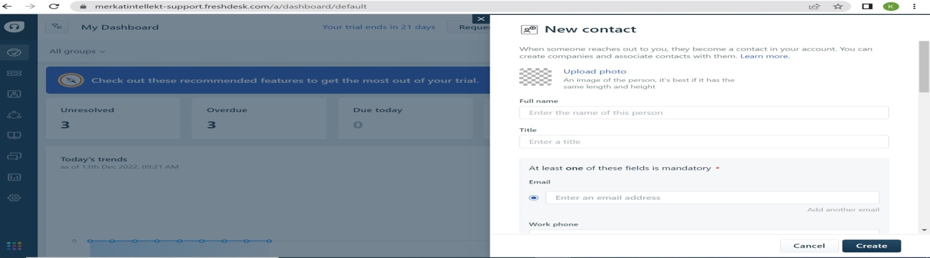

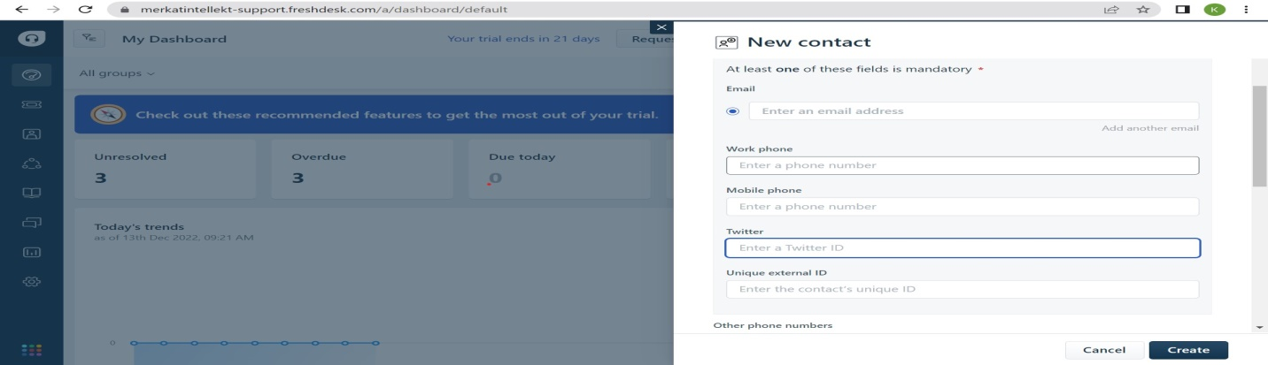

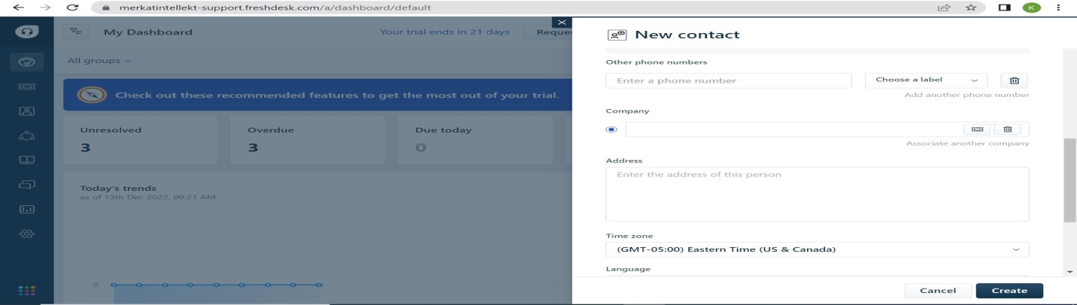

**Main search bar**

In this search bar, we can search the data for (Tickets, contacts, Solutions, Forums)

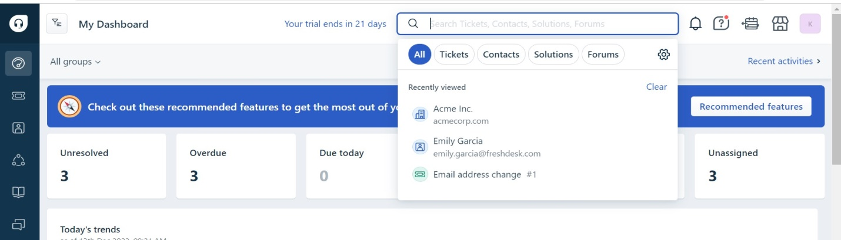

## Overall dashboard Represented

Generated tickets split into different category like (unresolved, overdue, open, close, on hold, unassigned)

We can see the counts for each category on the dashboard. And see the monthly chart we can able to get data from particular date.

Customer satisfaction is major part of customer success. The performance is divided by various methods like (Resolved, Average first response time, Average response time, Resolution within SLA %)

**Tickets**

**In freshdesk customer success, they have received the tickets from different fields**

All tickets are displayed in this page. We can filter the tickets by category

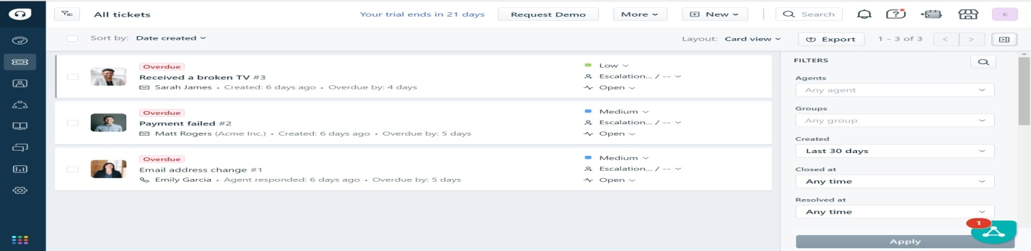

Click on ticket, It will show the details of ticket. The ticket we can receive them through the mail. We can also reply to the ticket by mail.

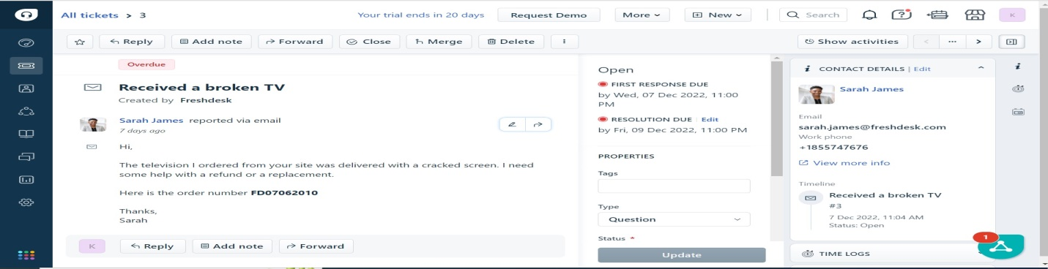

Click on view more info in contact details, It will show the full details of customer

